1.Display name from contact details using this. state. Initially enter id, name and address of 3 persons.

import React from "react";

class App extends React.Component {

  constructor(props) {

    super(props);

    // We declare the state as shown below

    this.state = {

      person1: {

        id: "1",

        name: "vasu",

        address: "xyz",

      },

      person2: {

        id: "2",

        name: "deepu",

        address: "yzx",

      },

      person3: {

        id: "3",

        name: "paru",

        address: "Zxy",

      },

    };

  }

  render() {

    let p1 = this.state.person1;

    let p2 = this.state.person2;

    let p3 = this.state.person3;

    return (

      <div

        style={{

          margin: "250px",

          color: "blue",

          border: "2px solid black",

          padding: "50px",

        }}

      >

        <h2 style={{ color: "red" }}>Contact details are:-</h2>

        <table style={{ border: "1px solid black" }}>

          <thead>

            <tr>

              <th style={{ border: "1px solid black" }}>id </th>

              <th style={{ border: "1px solid black" }}>name</th>

              <th style={{ border: "1px solid black" }}>address</th>

            </tr>

          </thead>

          <tbody>

            <tr>

              <td style={{ border: "1px solid black" }}>{p1.id}</td>

              <td style={{ border: "1px solid black" }}>{p1.name}</td>

              <td style={{ border: "1px solid black" }}>{p1.address}</td>

            </tr>

            <tr>

              <td style={{ border: "1px solid black" }}>{p2.id}</td>

              <td style={{ border: "1px solid black" }}>{p2.name}</td>

              <td style={{ border: "1px solid black" }}>{p2.address}</td>

            </tr>

            <tr>

              <td style={{ border: "1px solid black" }}>{p3.id}</td>

              <td style={{ border: "1px solid black" }}>{p3.name}</td>

              <td style={{ border: "1px solid black" }}>{p3.address}</td>

            </tr>

          </tbody>

        </table>

      </div>

    );

  }

}

export default App;

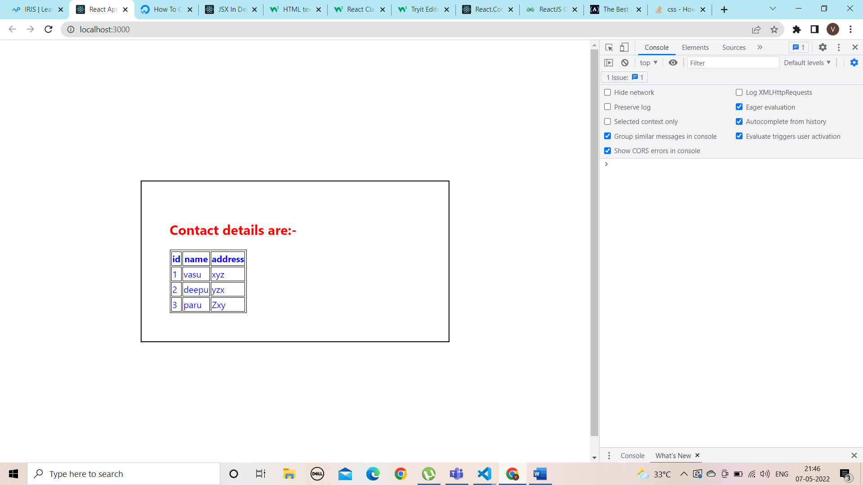

2. Create a toggle button for each person. On Clicking of the person the personal details should toggle .display this using state.

import React from "react";

class App extends React.Component {

  constructor(props) {

    super(props);

    // We declare the state as shown below

    this.state = {

      person1: {

        id: "1",

        name: "vasu",

        address: "xyz",

      },

      person2: {

        id: "2",

        name: "deepu",

        address: "yzx",

      },

      person3: {

        id: "3",

        name: "paru",

        address: "Zxy",

      },

    };

  }

  b1() {

    document.getElementById("e1").style.visibility = "visible";

  }

  b2() {

    document.getElementById("e2").style.visibility = "visible";

  }

  b3() {

    document.getElementById("e3").style.visibility = "visible";

  }

  render() {

    let p1 = this.state.person1;

    let p2 = this.state.person2;

    let p3 = this.state.person3;

    return (

      <div

        style={{

          margin: "250px",

          color: "blue",

          border: "2px solid black",

          padding: "50px",

        }}

      >

        <h2>cleck the button to see details </h2>

        <button onClick={this.b1}>person1</button>

        <button onClick={this.b2}>person2</button>

        <button onClick={this.b3}>person3</button>

        <h2 style={{ color: "red" }}>Contact details are:-</h2>

        <table style={{ border: "1px solid black" }}>

          <thead>

            <tr>

              <th style={{ border: "1px solid black" }}>id </th>

              <th style={{ border: "1px solid black" }}>name</th>

              <th style={{ border: "1px solid black" }}>address</th>

            </tr>

          </thead>

          <tbody>

            <tr id="e1" style={{ visibility: "hidden" }}>

              <td style={{ border: "1px solid black" }}>{p1.id}</td>

              <td style={{ border: "1px solid black" }}>{p1.name}</td>

              <td style={{ border: "1px solid black" }}>{p1.address}</td>

            </tr>

            <tr id="e2" style={{ visibility: "hidden" }}>

              <td style={{ border: "1px solid black" }}>{p2.id}</td>

              <td style={{ border: "1px solid black" }}>{p2.name}</td>

              <td style={{ border: "1px solid black" }}>{p2.address}</td>

            </tr>

            <tr id="e3" style={{ visibility: "hidden" }}>

              <td style={{ border: "1px solid black" }}>{p3.id}</td>

              <td style={{ border: "1px solid black" }}>{p3.name}</td>

              <td style={{ border: "1px solid black" }}>{p3.address}</td>

            </tr>

          </tbody>

        </table>

      </div>

    );

  }

}

export default App;

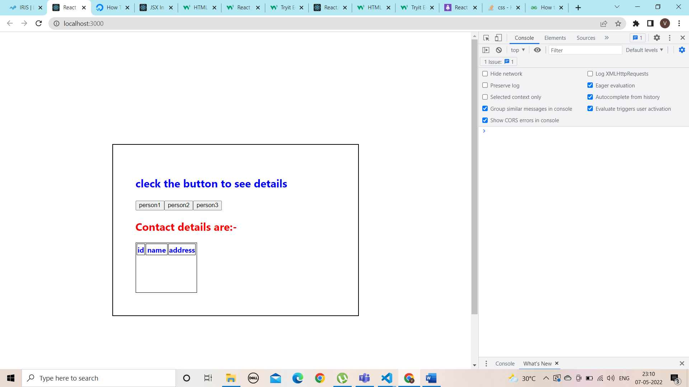

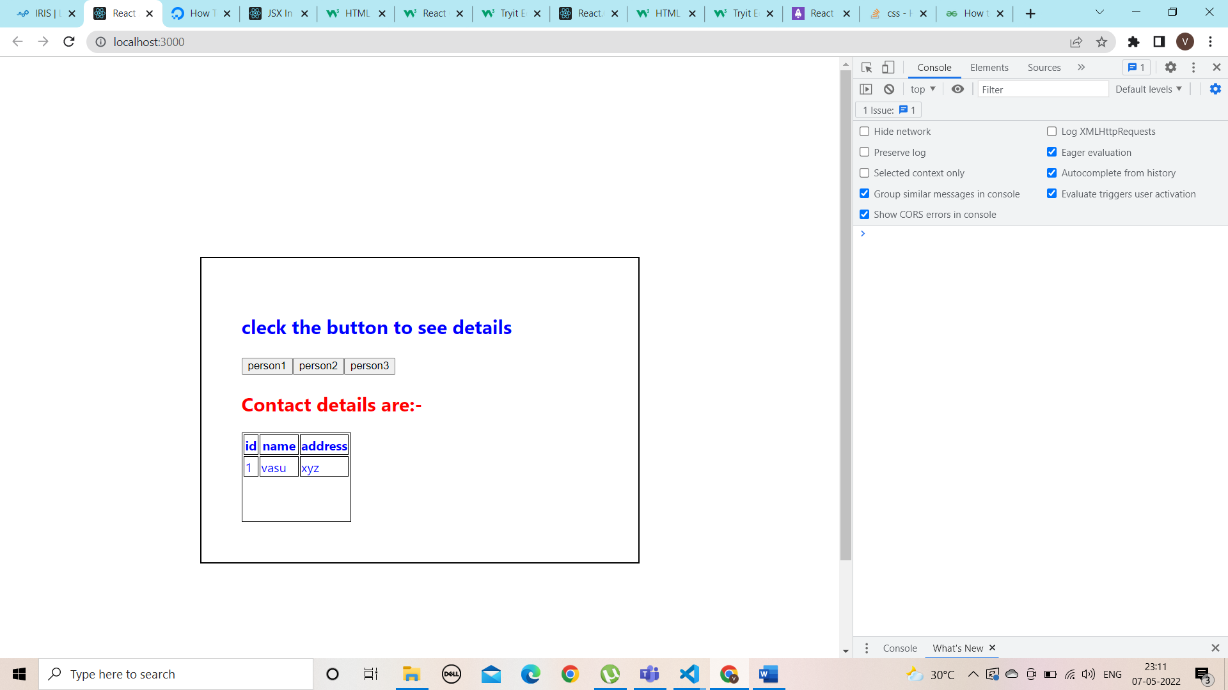

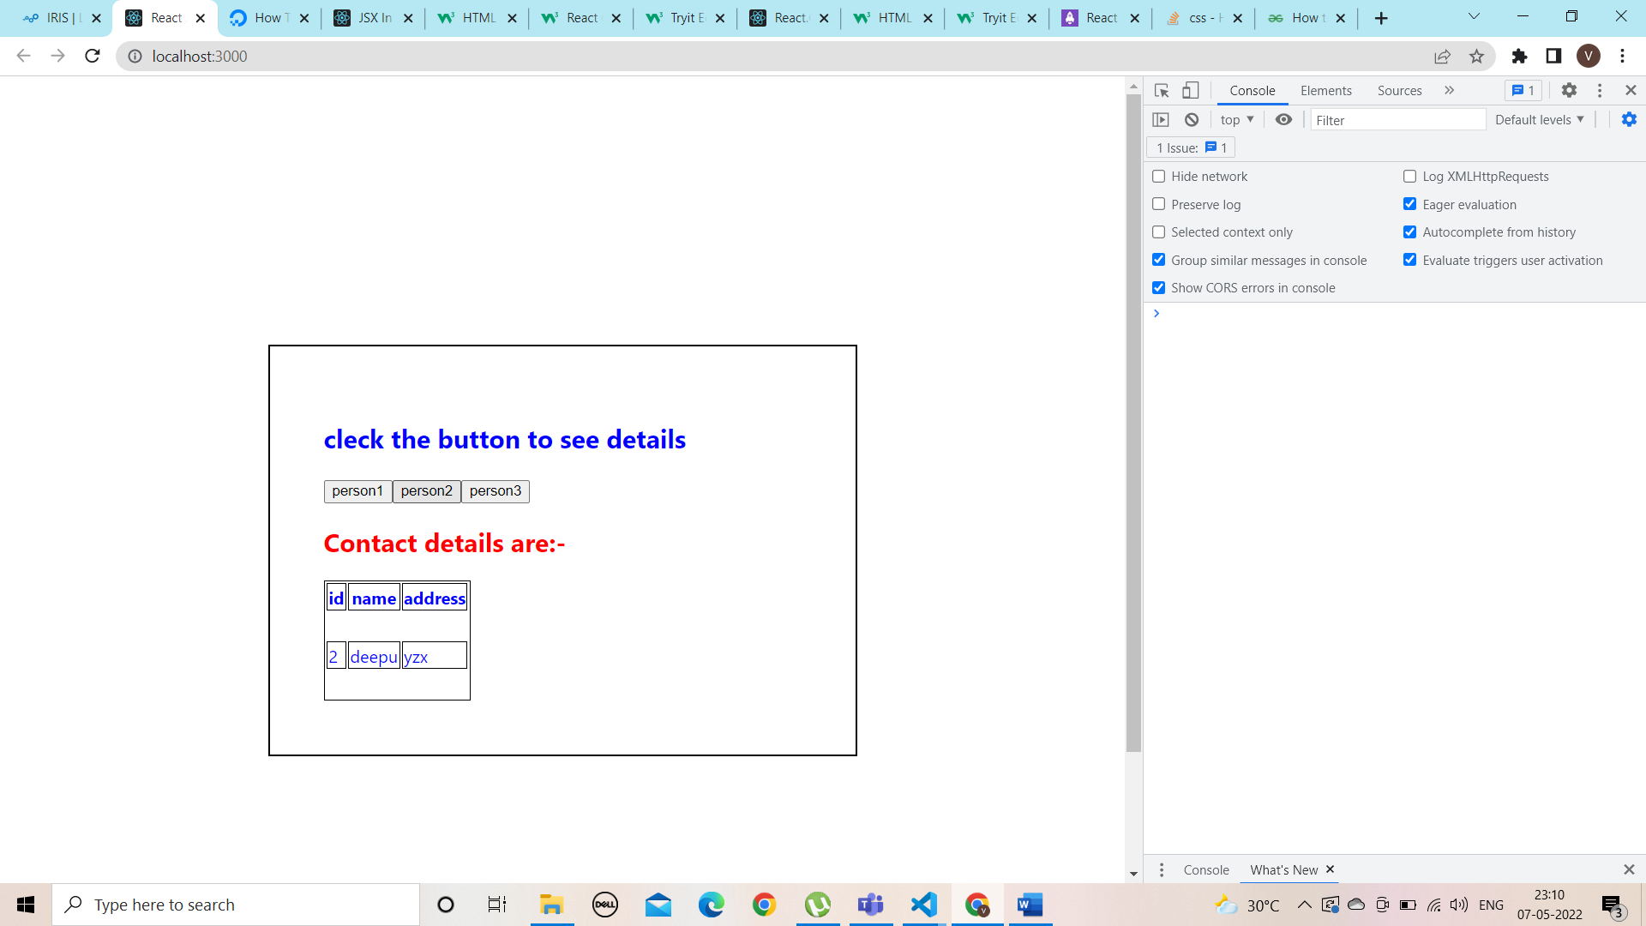

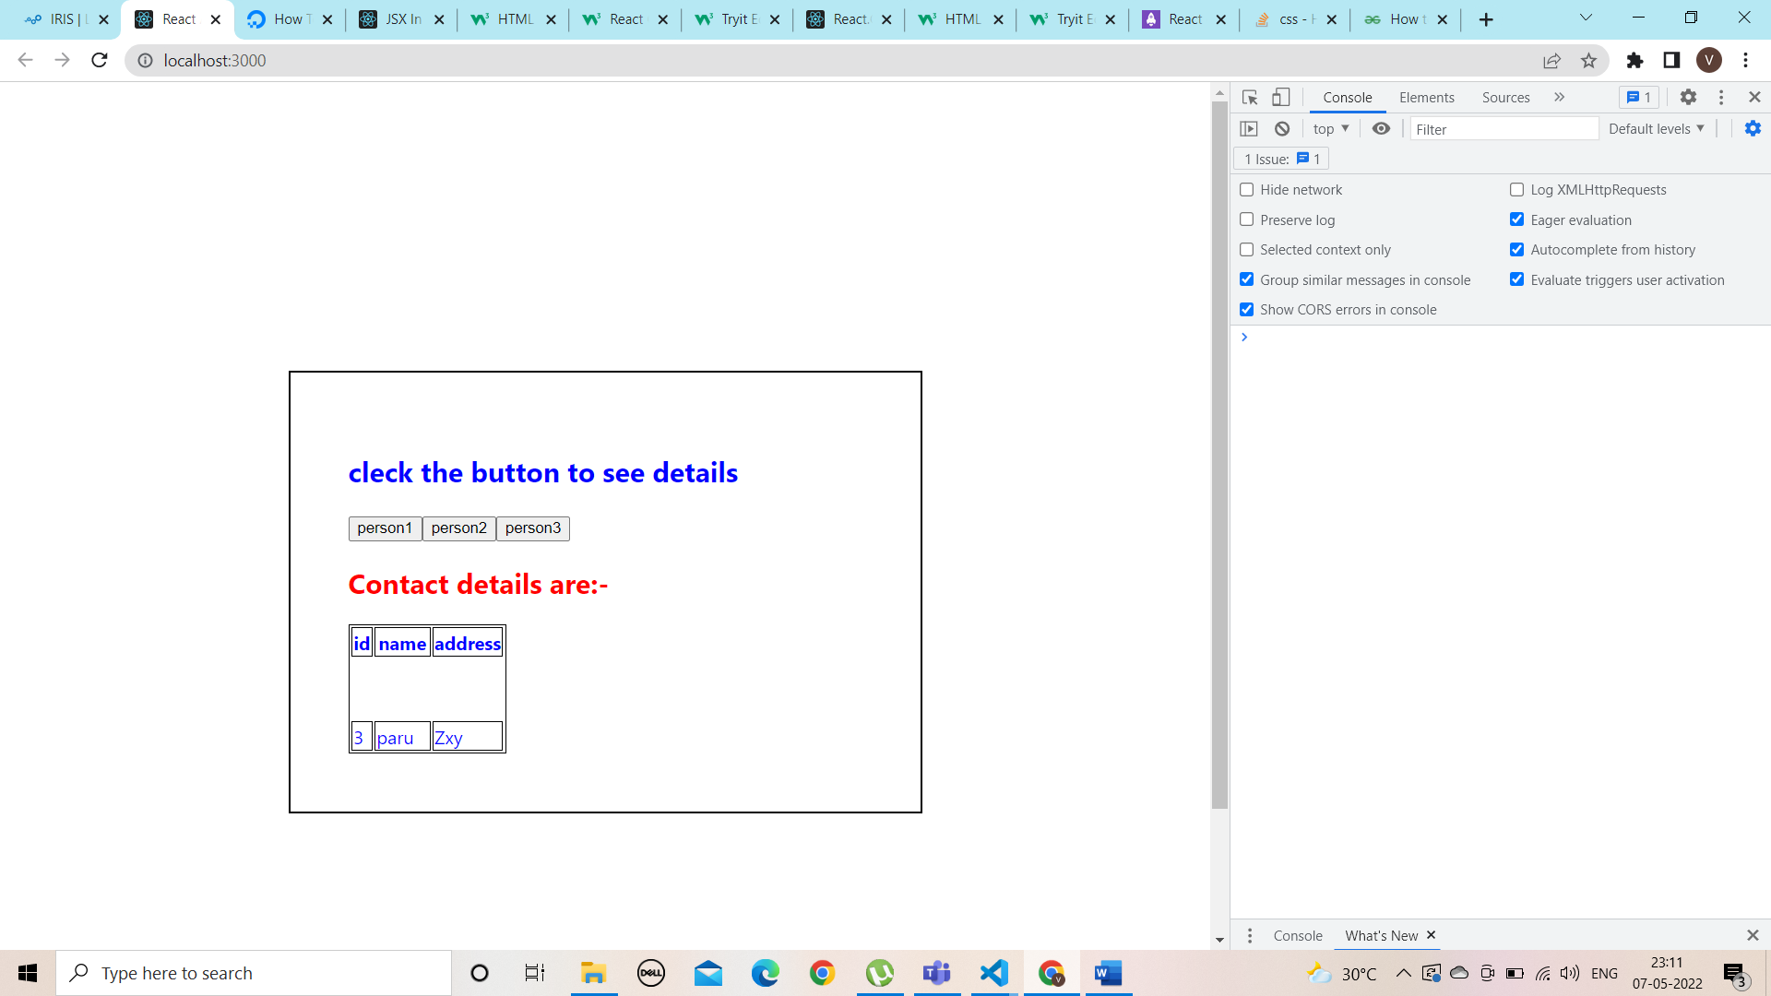

3. Create a toggle event using this.setState() . change the state from true to false on clicking on the toggle button.

import React from "react";

class Counter extends React.Component {

  render() {

    return (

      <div>

        <Button text="Hello"> </Button>

      </div>

    );

  }

}

class Button extends React.Component {

  state = {

    textflag: false,

  };

  ToggleButton() {

    this.setState({ textflag: !this.state.textflag });

  }

  render() {

    return (

      <div>

        <button onClick={() => this.ToggleButton()}>

          {this.state.textflag === false ? "Hide" : "Show"}

        </button>

        {!this.state.textflag && this.props.text}

      </div>

    );

  }

}

export default Counter;

